Semi-Automatic 1 head Filling Machine 10ML to 5 Litr
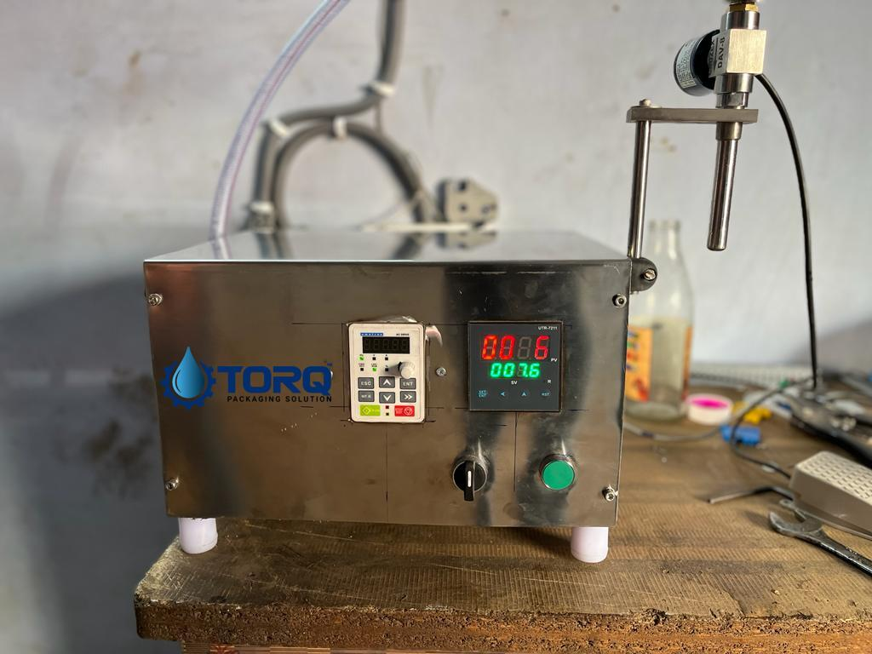
Description
Machine is design for small to medium filling and work on timer base technologies. Nozzle on off by accurate solenoid valve.
Operation
This machine takes material from overhead tank or ground base tank where, material come by pump. Pump speed will be adjusted by VFD(variable frequency drive)
When we place container under nozzle, controller take zero and give signal for filling. After filling exact weight which is adjustable , will close the valve and stop filling.
Technical Specifications
Valve Diameter |  | 20mm
Number of nozzels |  | 1
Machine size |  | 300 x 380 x 250(H) mm
Machine Height |  | 250 mm
Filling System |  | Rotary gear pump(SS316)
Power Consumption |  | 230 V a.c.
Output per Min |  | 10 to 40 BPM
Salient Features
- ±1 % Filling accuracy on single dose.
- All Contact Parts made of S.S.316
- Rigid vibration free construction for trouble free performance
- A unit to fill variety of liquid and can be used for various types of container
- Total GMP model.
- PLC controller Base system
- 0.5 HP SS 316 gear pump
Utility Requirement
Electrical supply | 1 Phase + Neutral + Earthing

